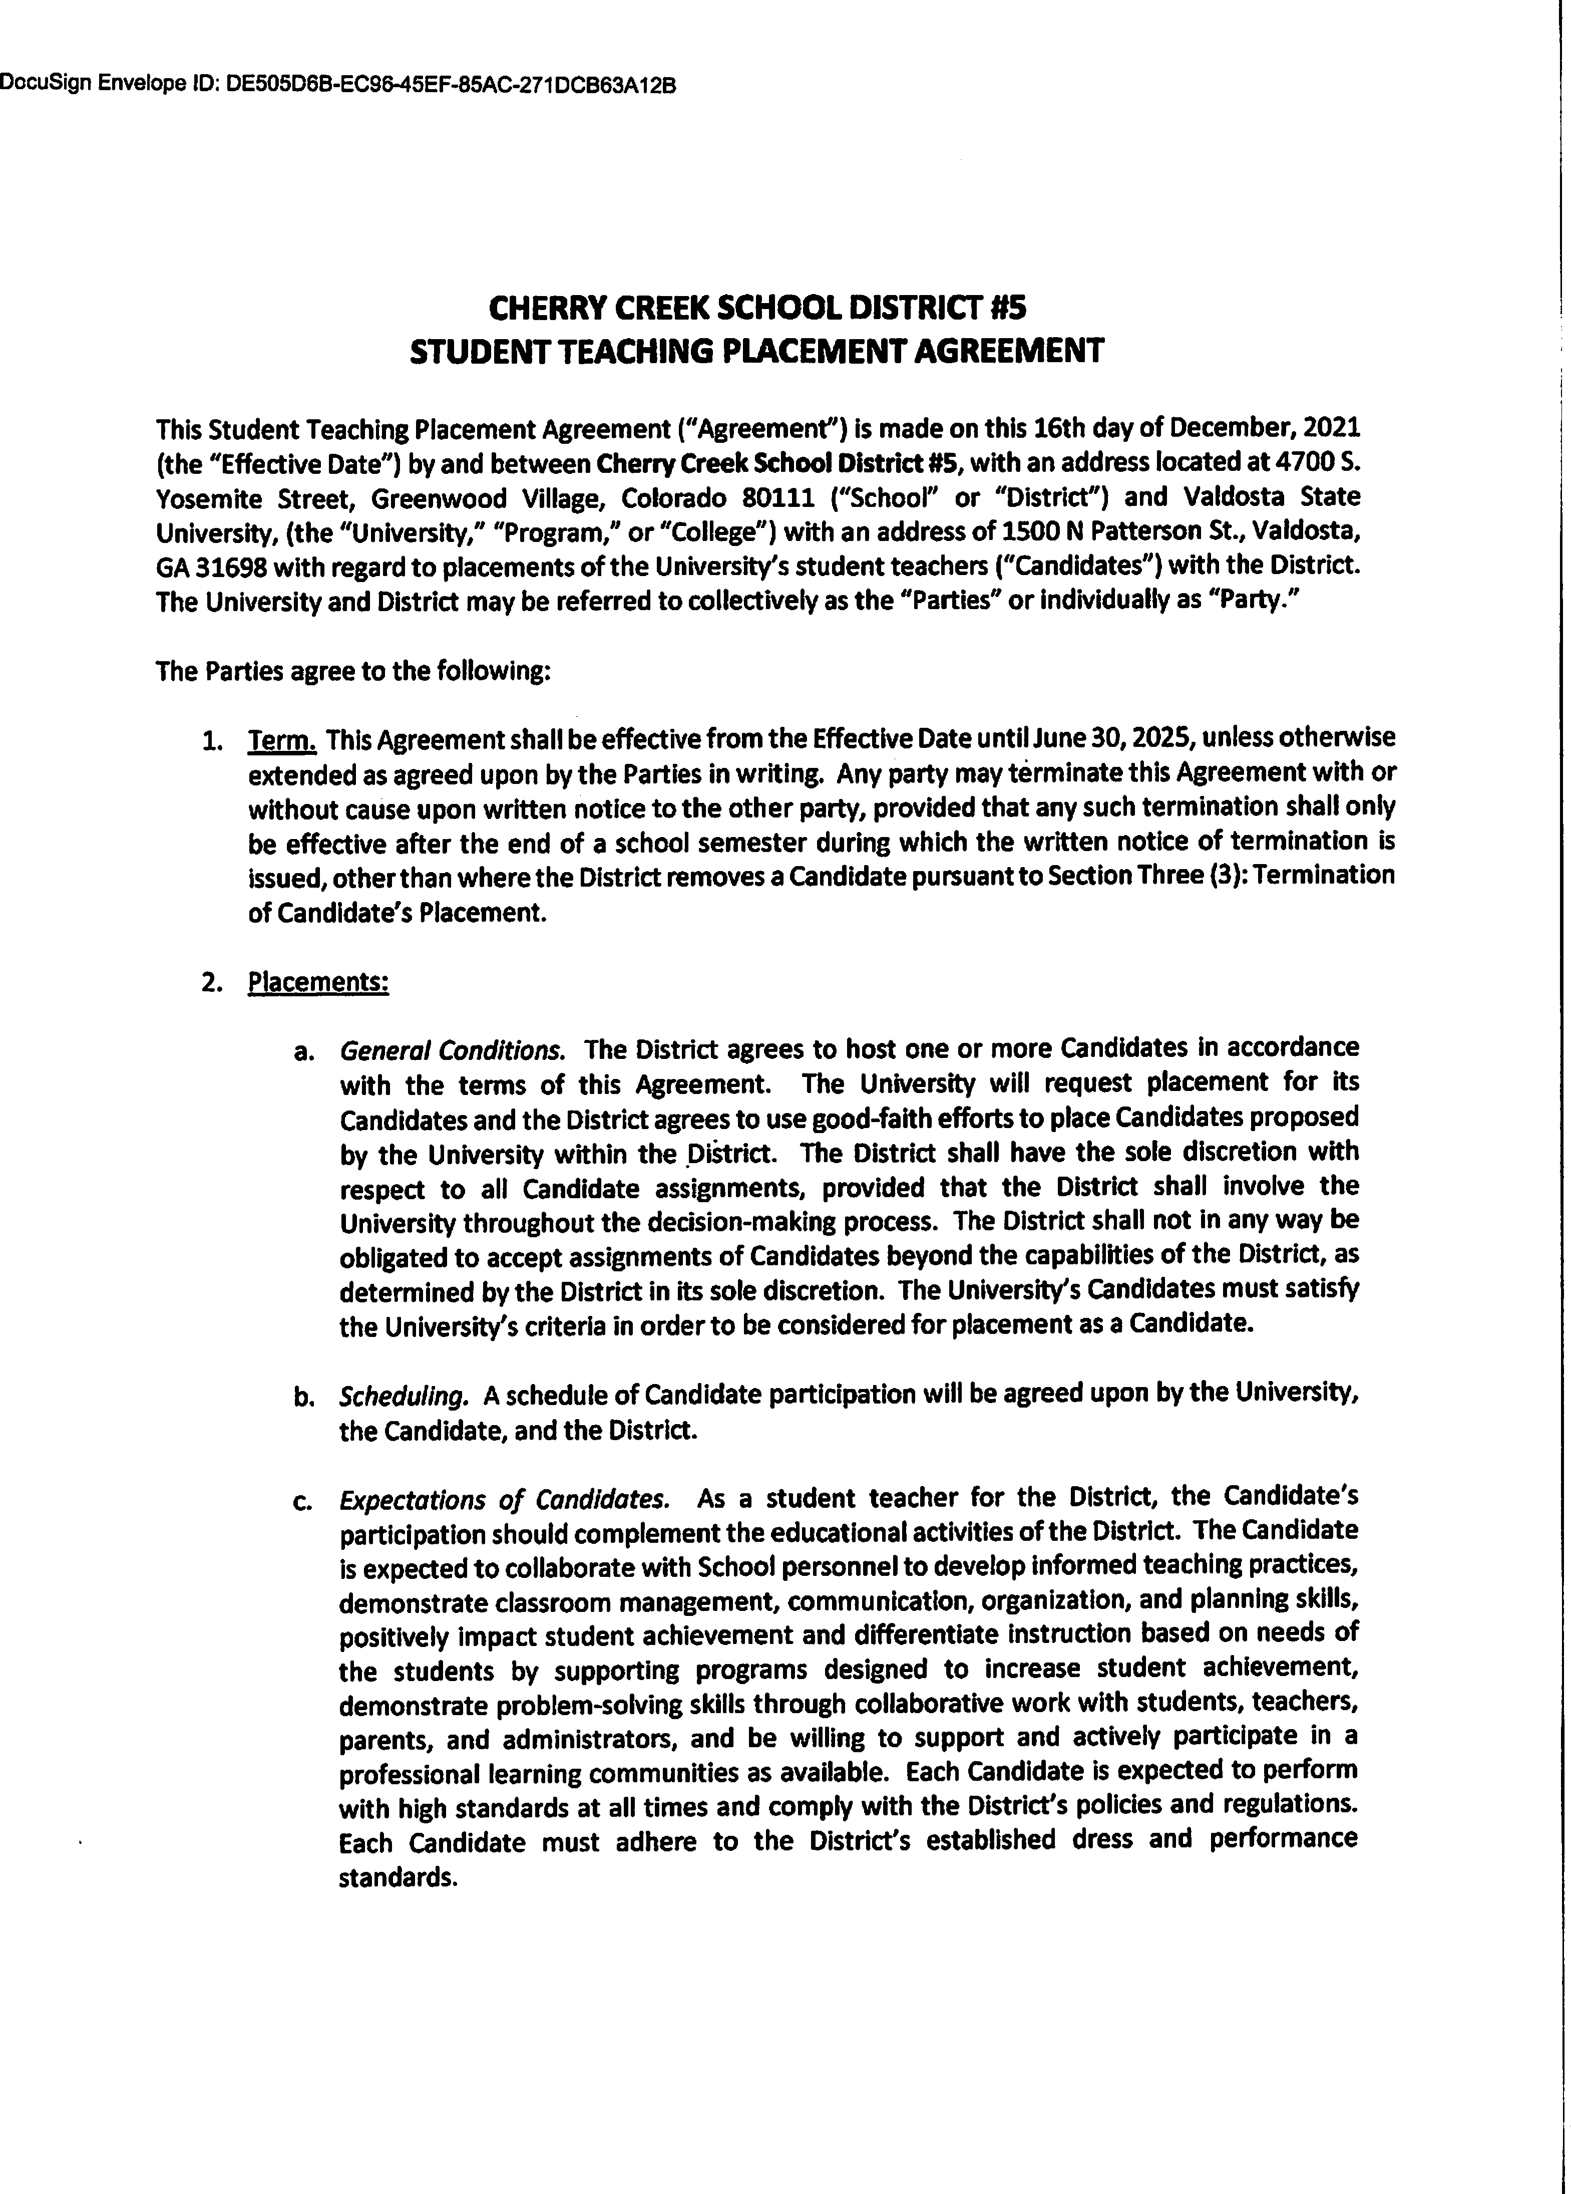

DocuSign Envelope ID: AC6E7F10-64DA-4E9F-B461-3DBE6563A289

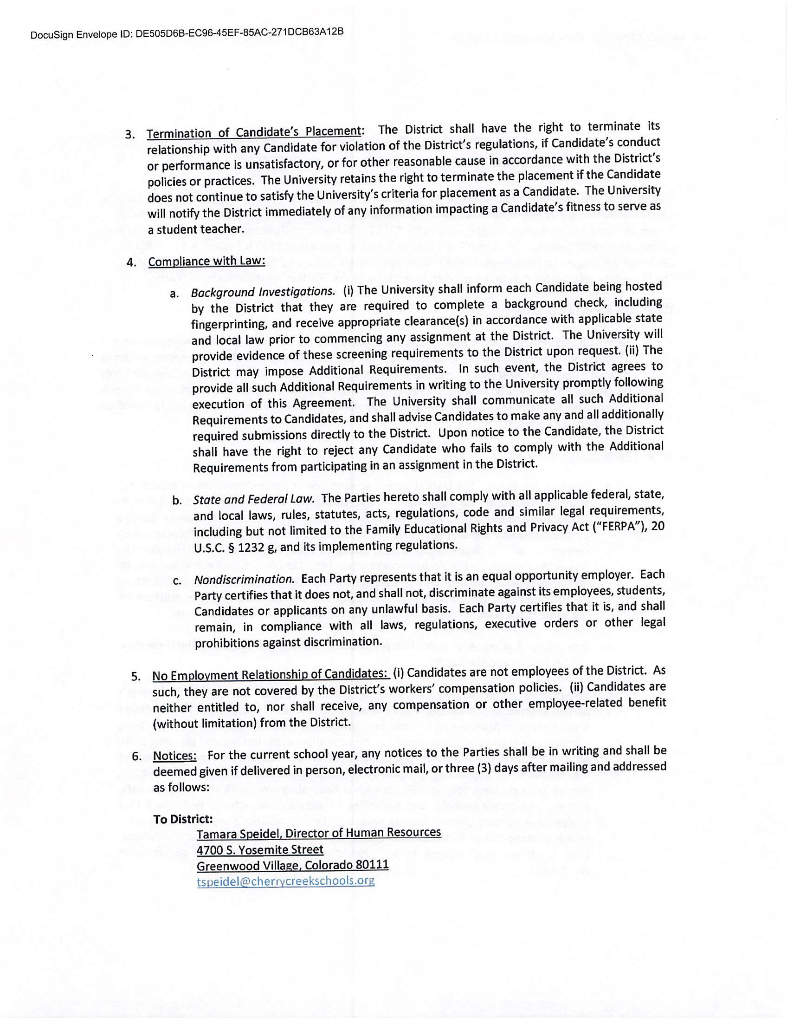

DocuSign Envelope ID: AC6E7F10-64DA-4E9F-B461-3DBE6563A289

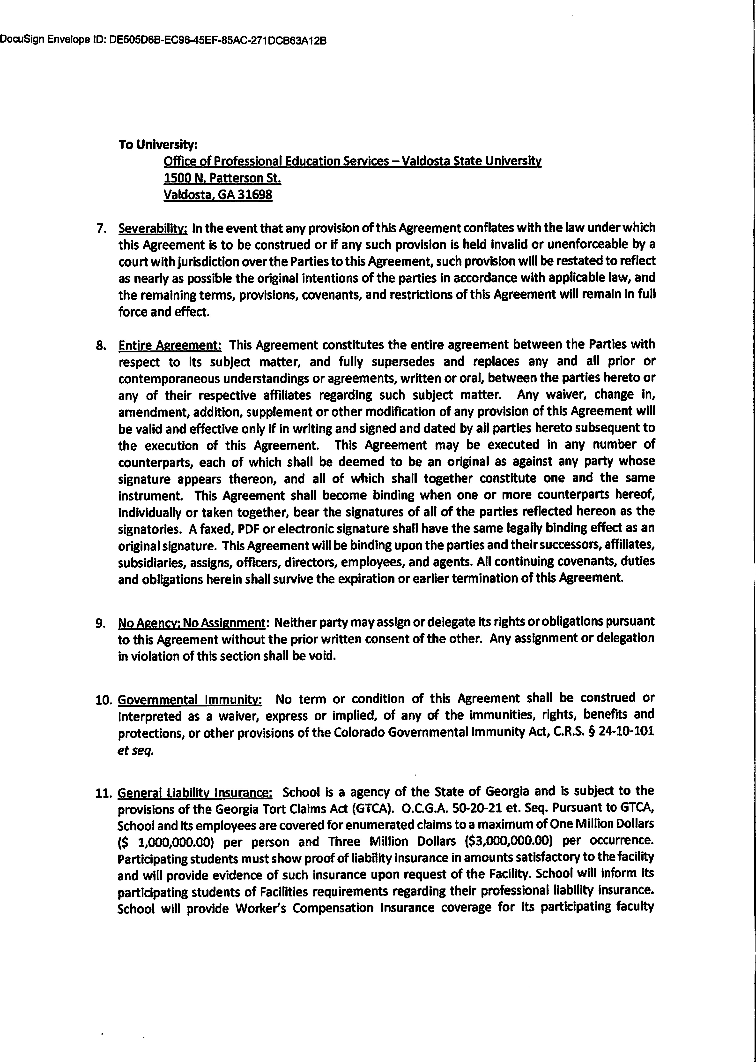

DocuSign Envelope ID: AC6E7F10-64DA-4E9F-B461-3DBE6563A289

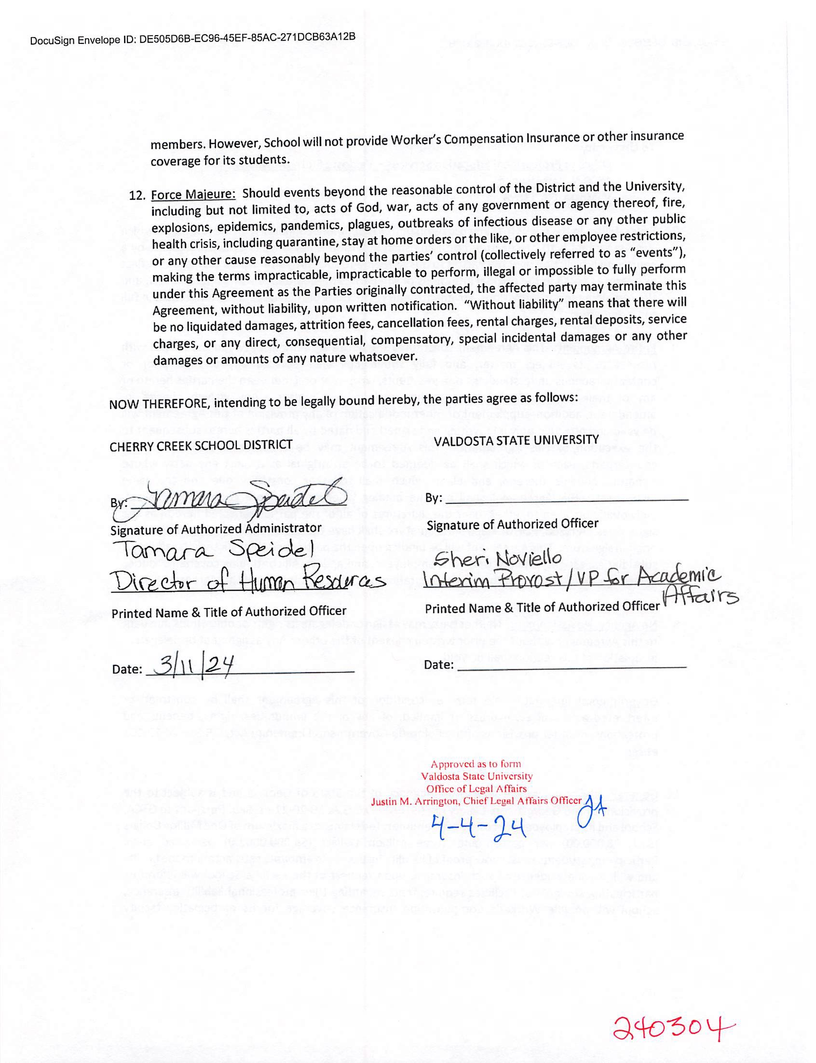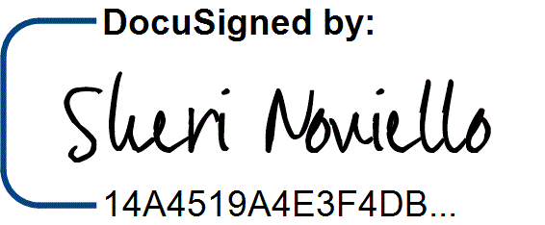

DocuSign Envelope ID: AC6E7F10-64DA-4E9F-B461-3DBE6563A289

4/7/2024 | 3:14 PM EDT