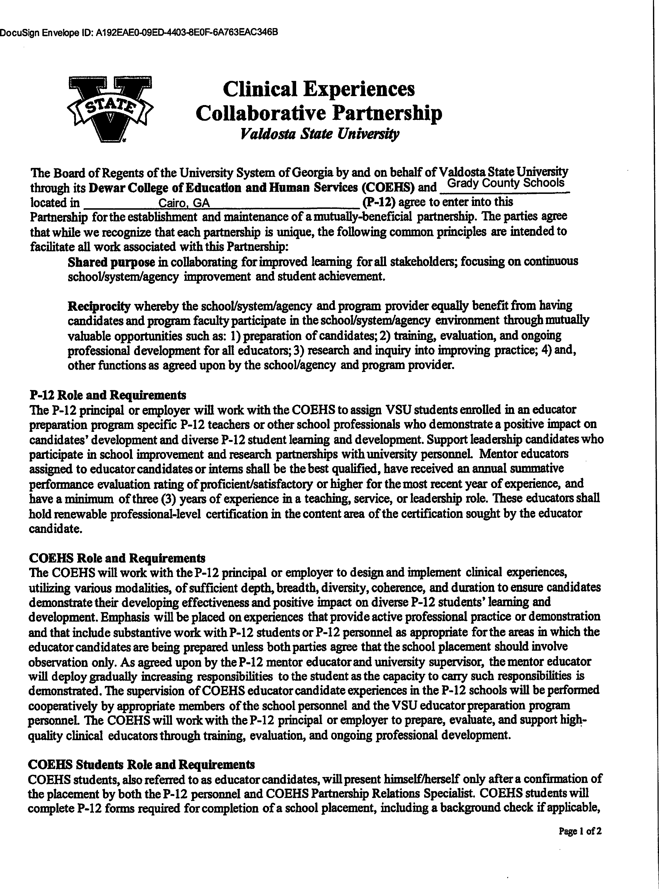

DocuSign Envelope ID: 2450B0D3-D71F-4421-9424-BD12591598DE

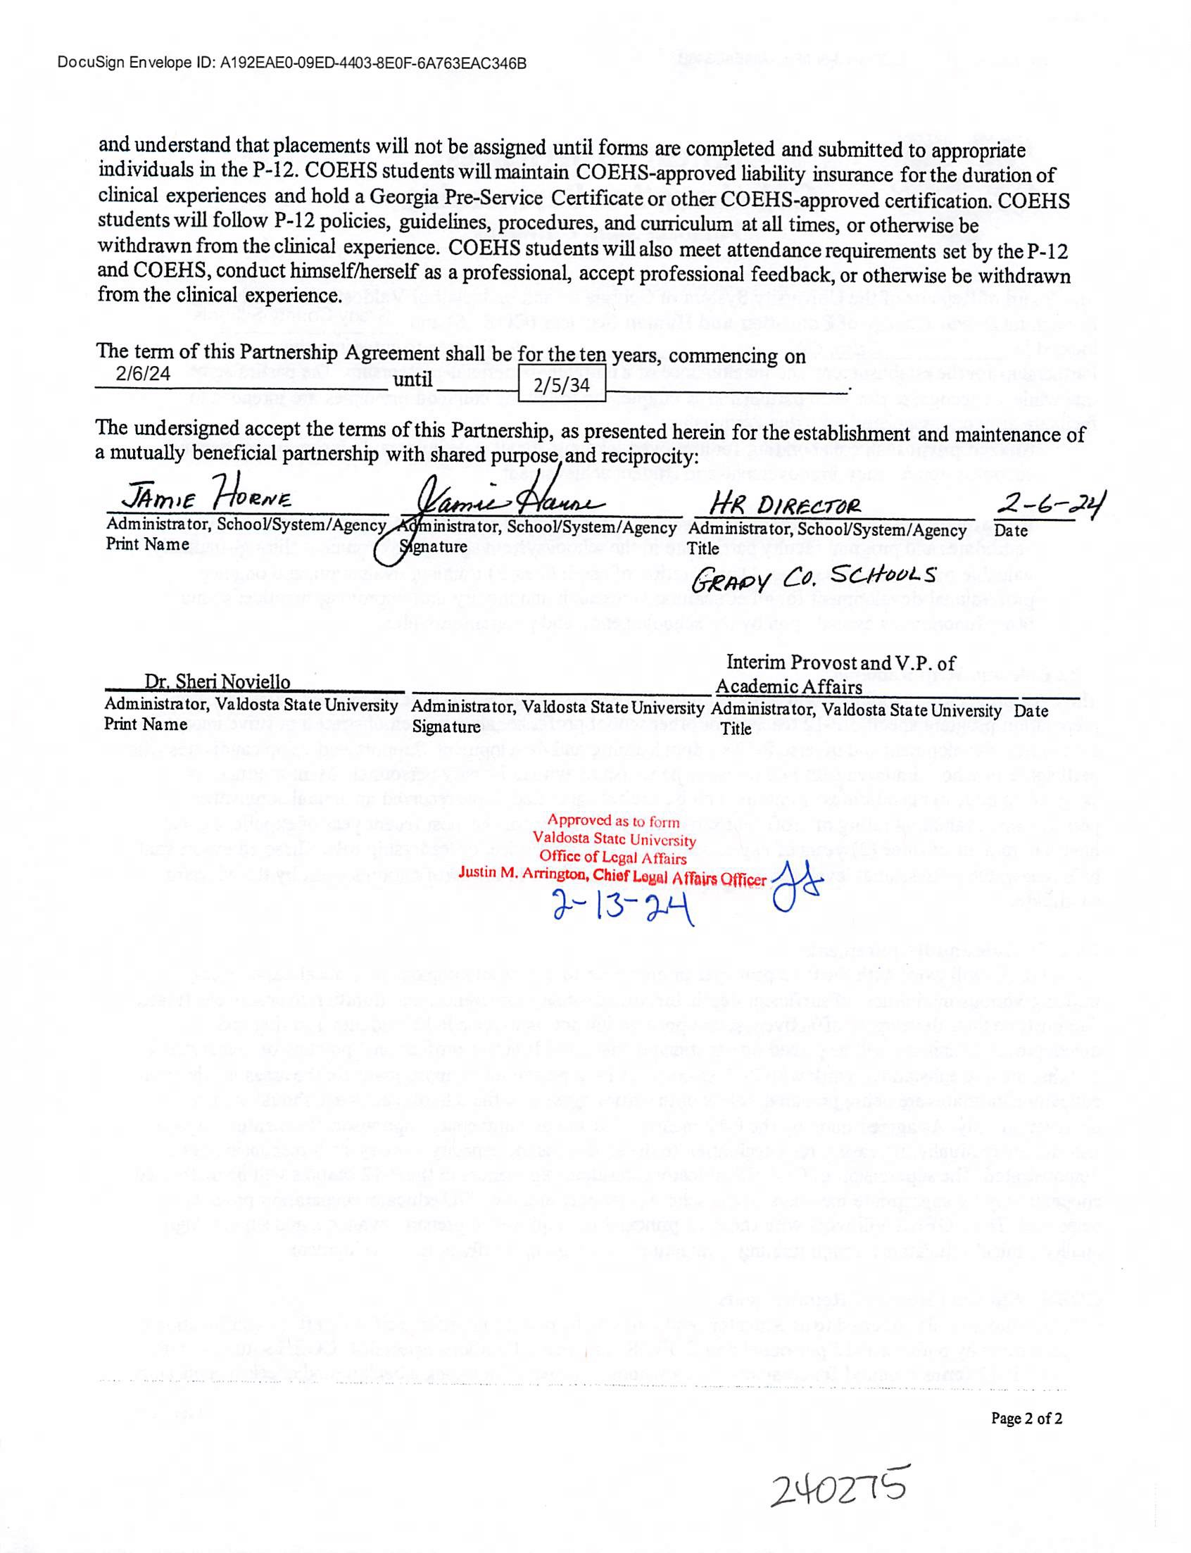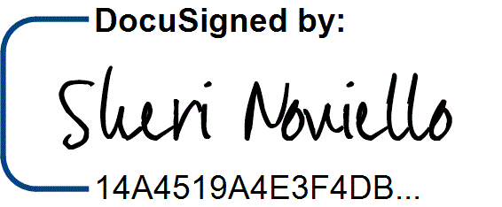

DocuSign Envelope ID: 2450B0D3-D71F-4421-9424-BD12591598DE

2/13/2024 | 7:28 PM ES