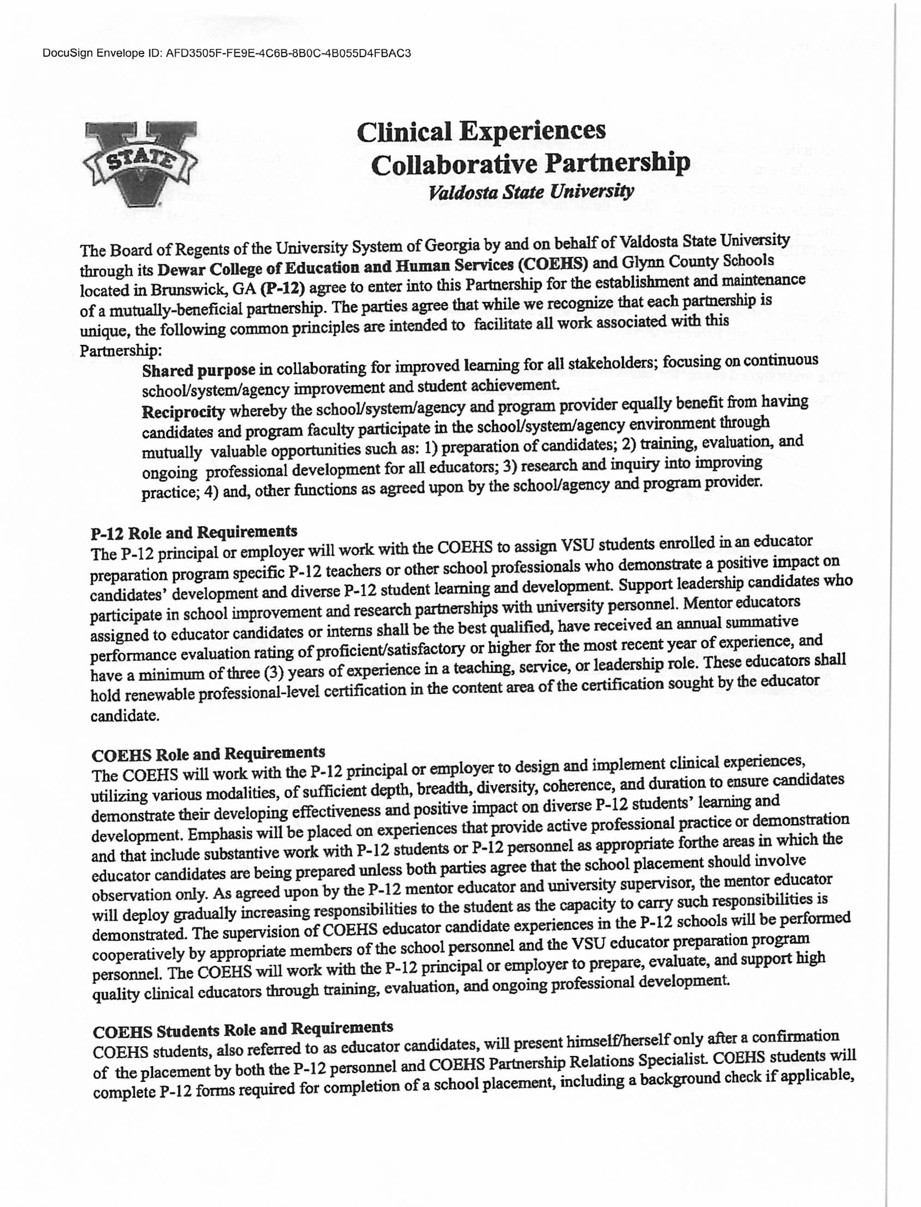

DocuSign Envelope ID: 4A5843D1-DBE5-4B56-8B77-3174BE6F356C

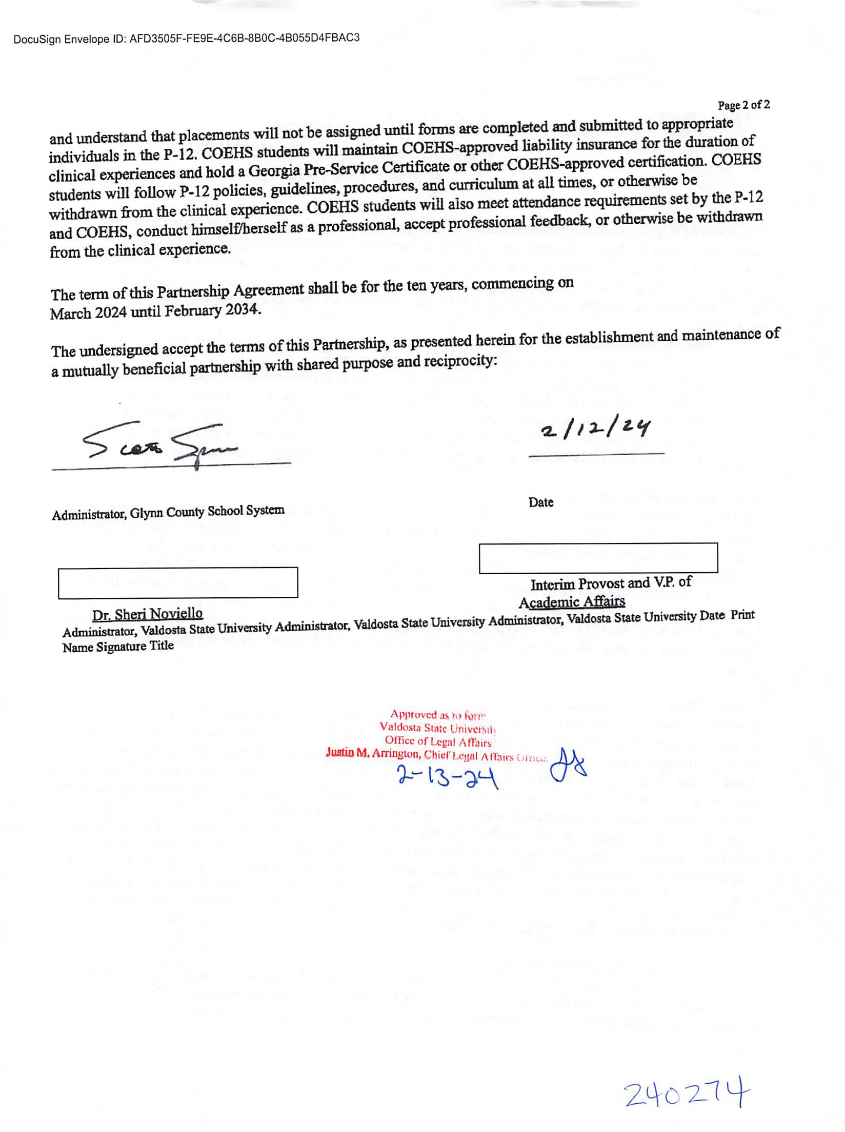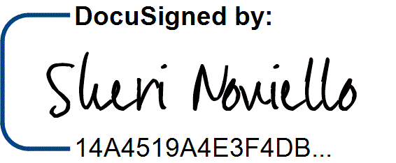

DocuSign Envelope ID: 4A5843D1-DBE5-4B56-8B77-3174BE6F356C

2/13/2024 | 7:27 PM EST