Approving an absence request for an employee
If a manager receives an error message when trying to approve an absence request, this means that the request must be approved on the timesheet using the below steps.
- Open the timesheet (Manager Self-Service Team Time Report/Approve Time OR Time Approver Time Approver Report/Approve Time) for the employee that needs the absence request approved
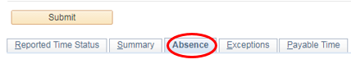
- Click the Absence tab below the Submit button

- Select the checkbox next to the absences that need approval
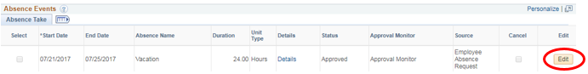

- Click Approve

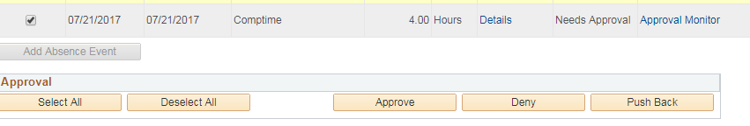

- If the approval options below are not available, please approve through the normal absence approval method (Manager Self-Service Team Time Absence Requests OR Time Approver Time Approver Absence Requests)

