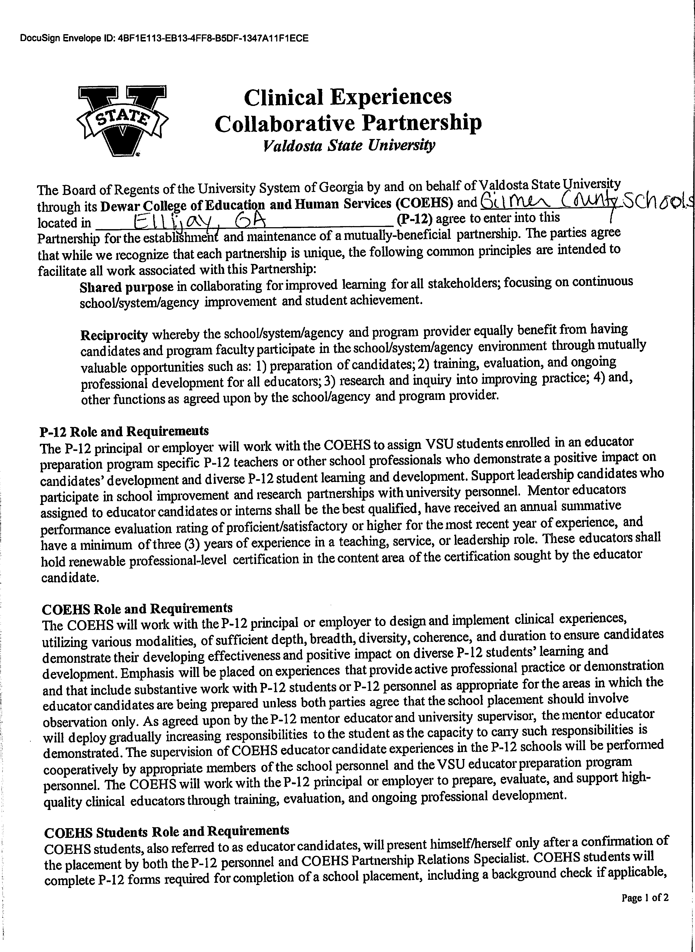

DocuSign Envelope ID: FBFA23C9-7BDC-4F45-90B4-4A8FC717D105

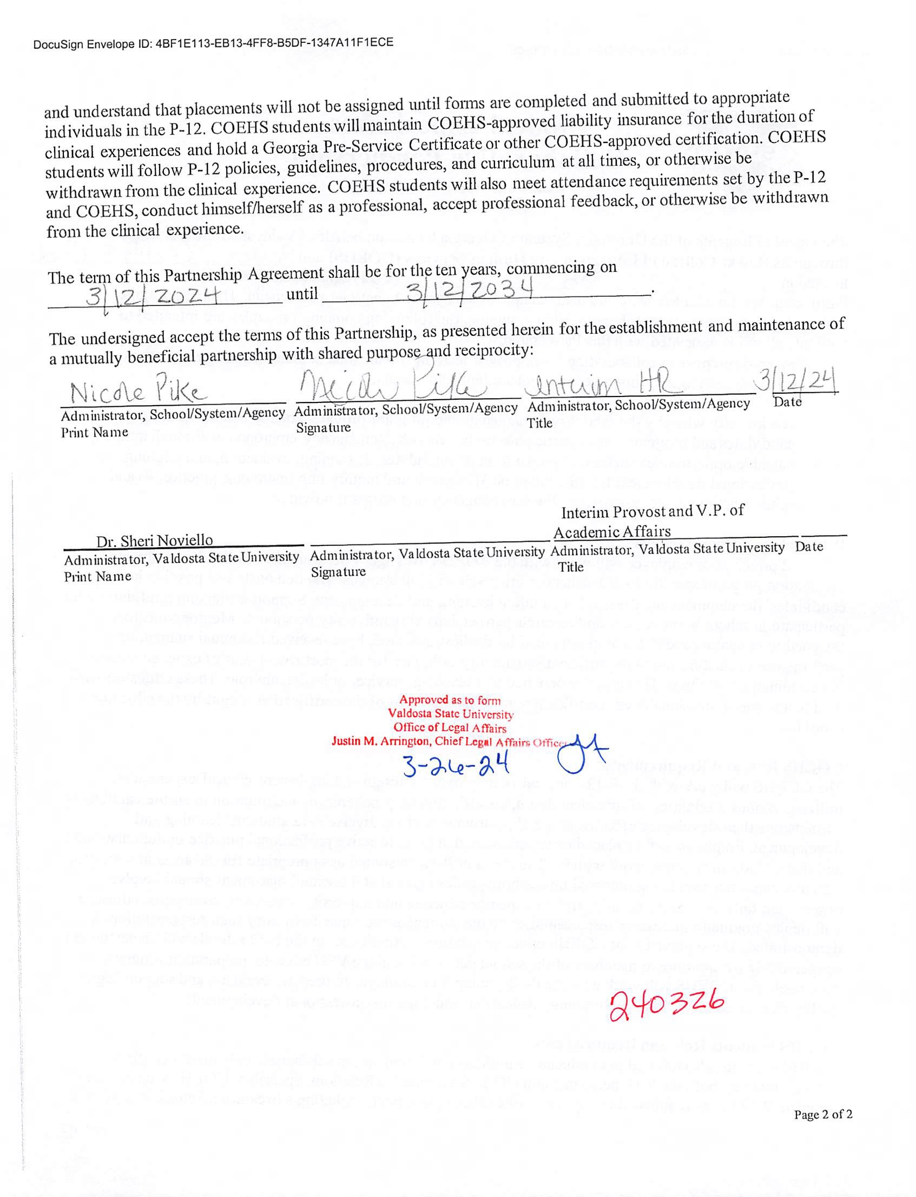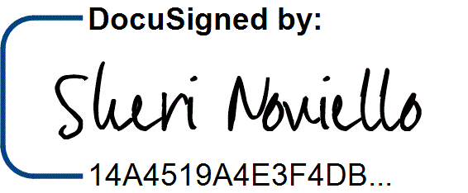

DocuSign Envelope ID: FBFA23C9-7BDC-4F45-90B4-4A8FC717D105

3/30/2024 | 7:32 AM