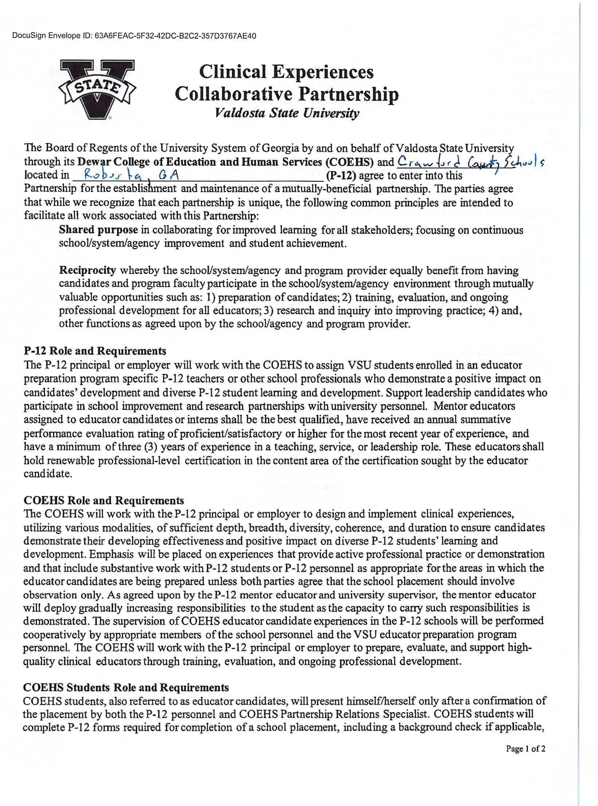

DocuSign Envelope ID: 796E18DA-ABE8-448C-BD99-B59E05F04555

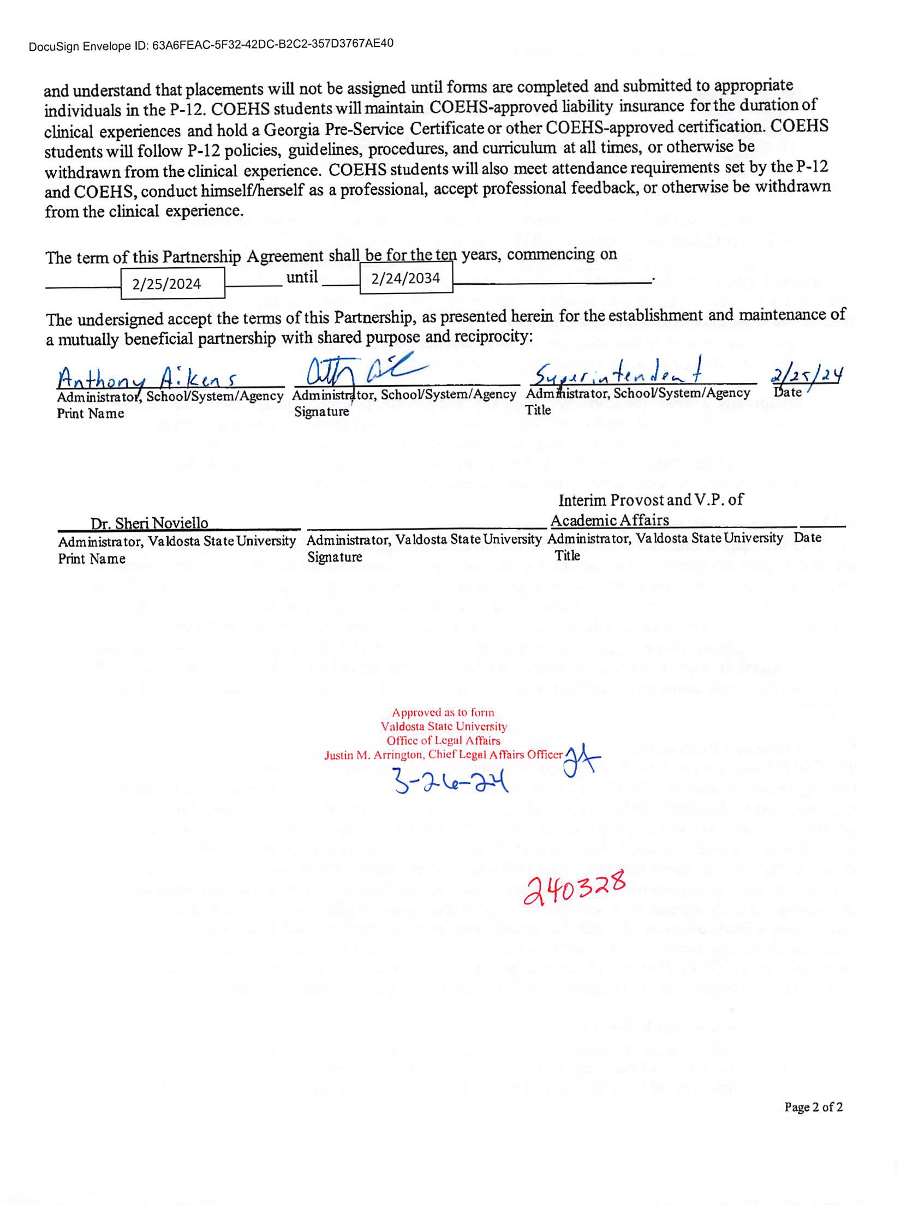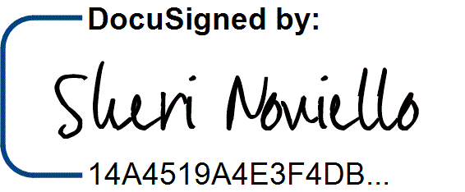

DocuSign Envelope ID: 796E18DA-ABE8-448C-BD99-B59E05F04555

3/30/2024 | 7:31 AM E