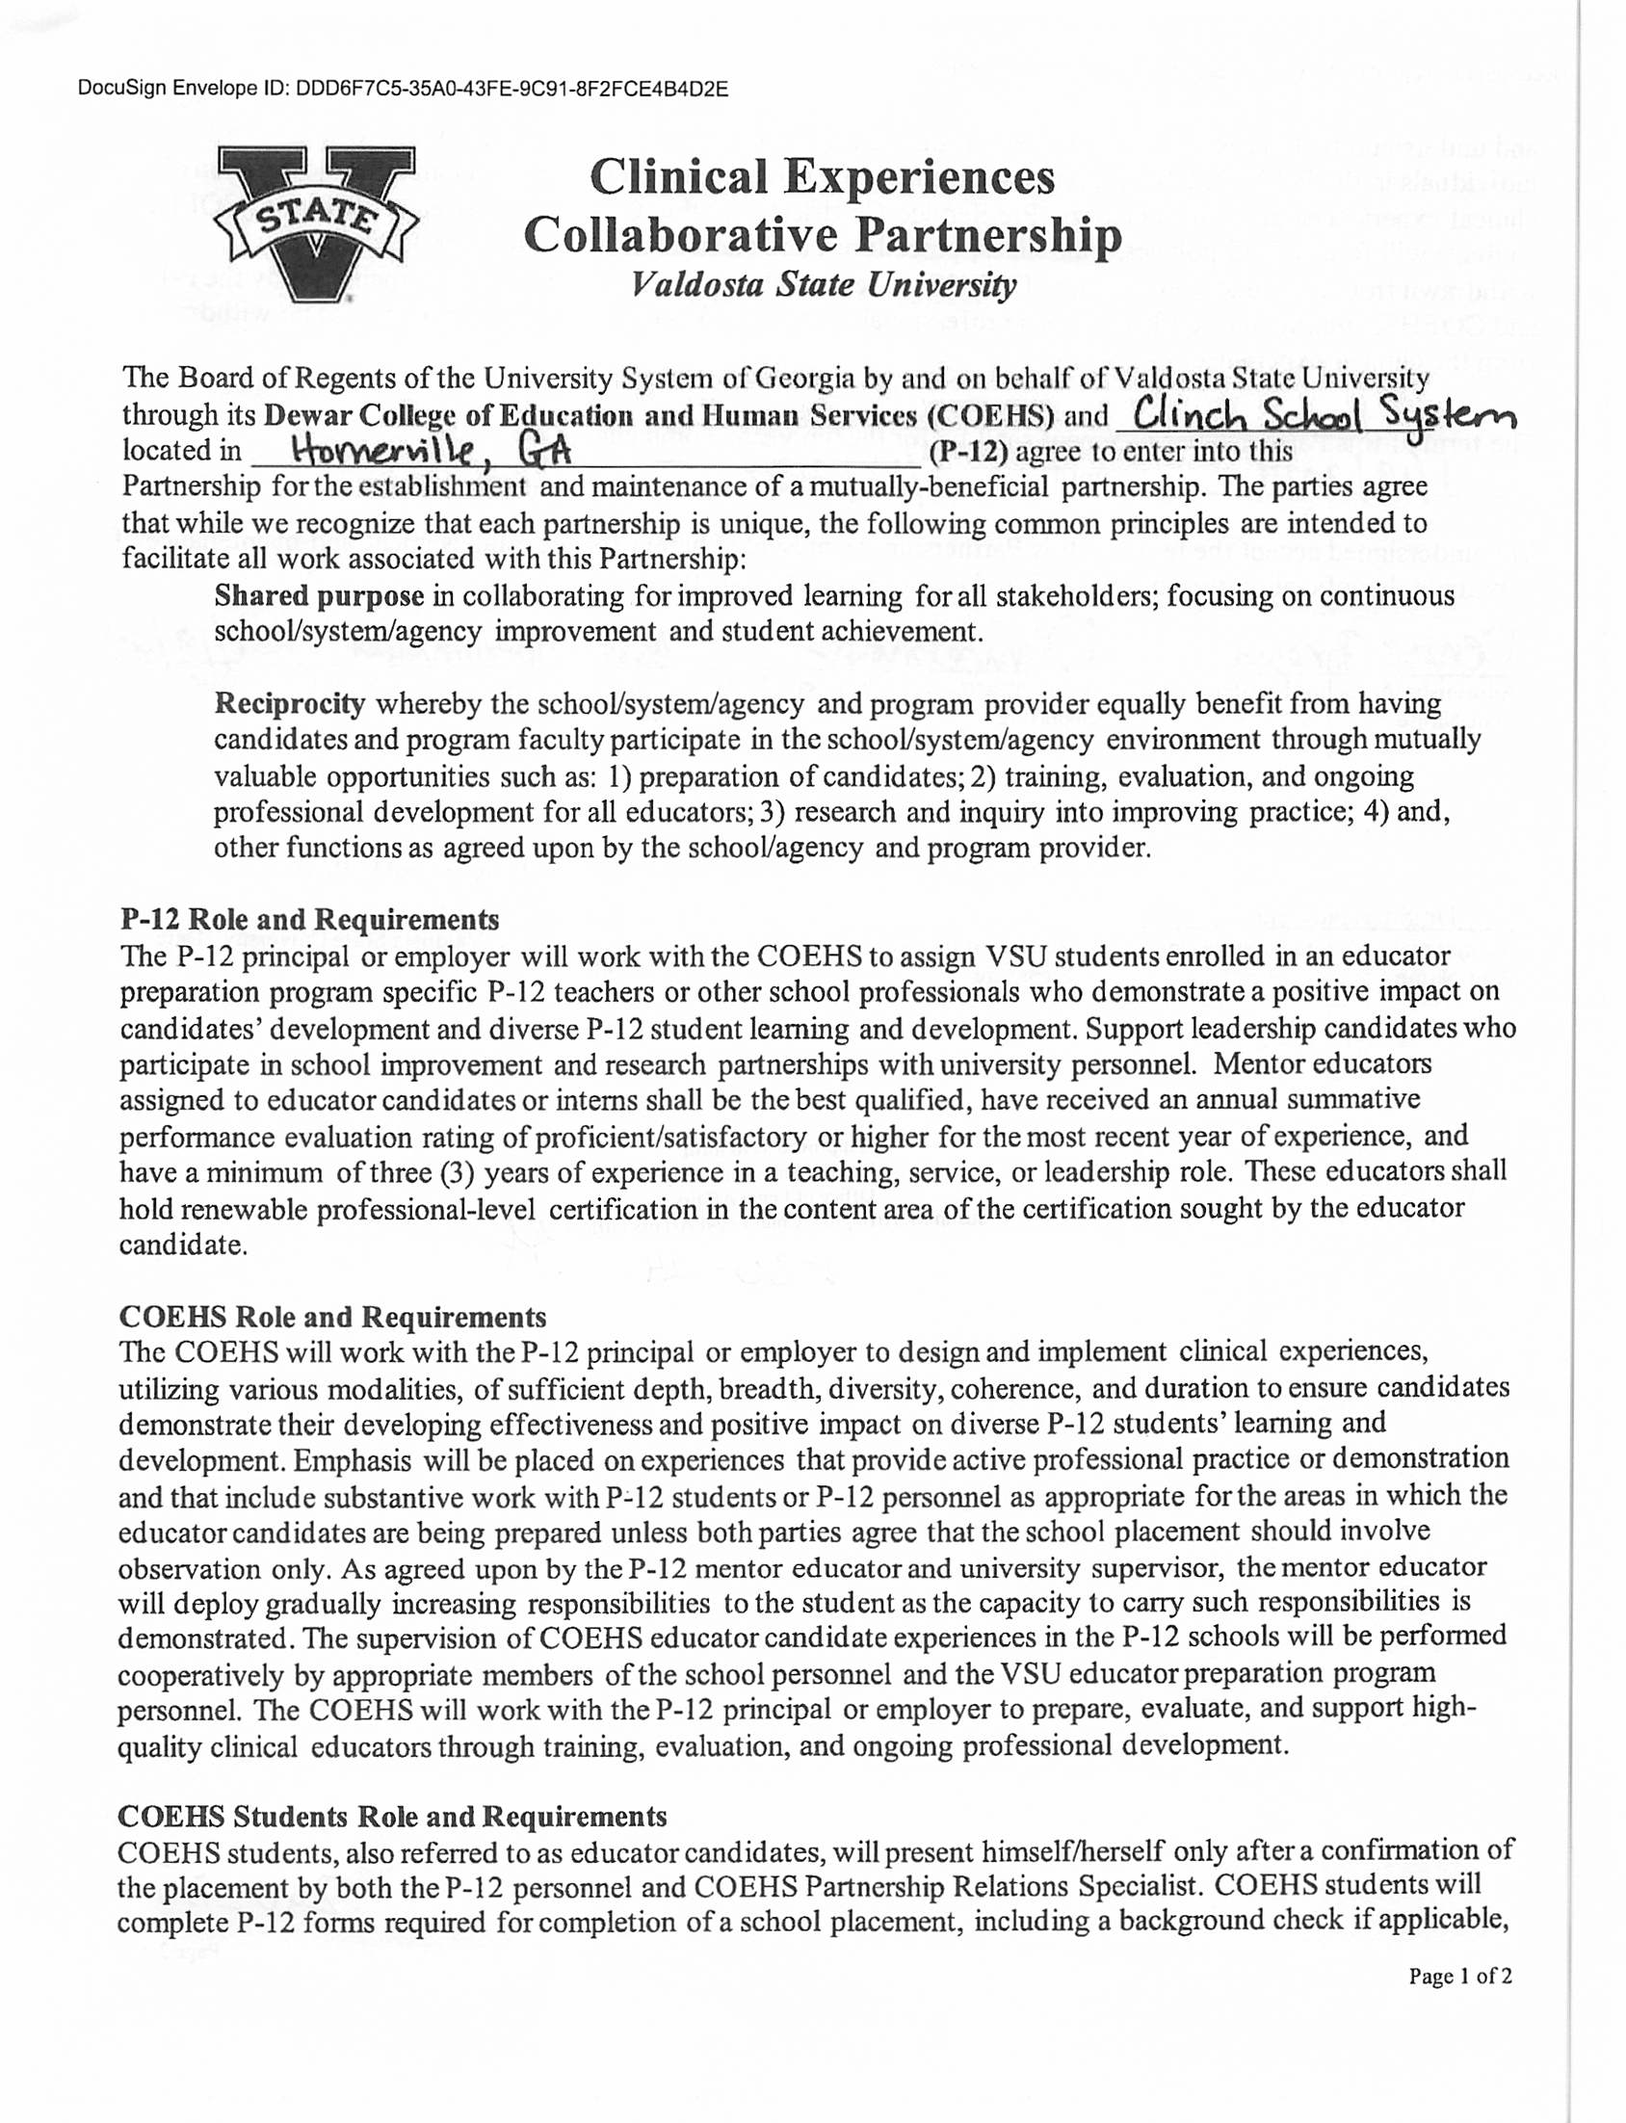

DocuSign Envelope ID: 17C2F726-DF00-4162-9686-4D80CDE571B9

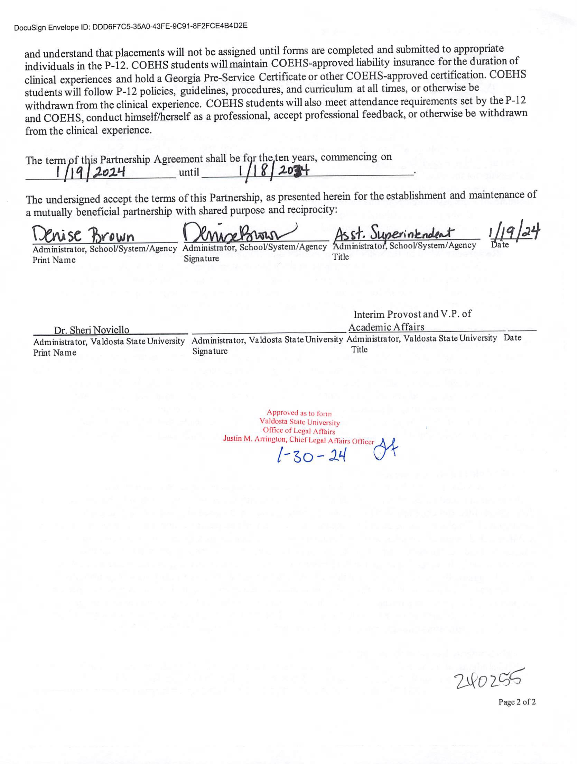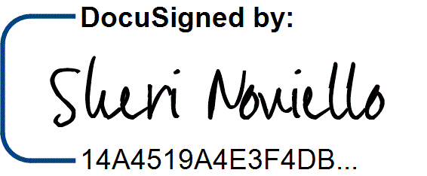

DocuSign Envelope ID: 17C2F726-DF00-4162-9686-4D80CDE571B9

2/1/2024 | 7:52 AM