Managing Timesheet Exceptions for Supervisors

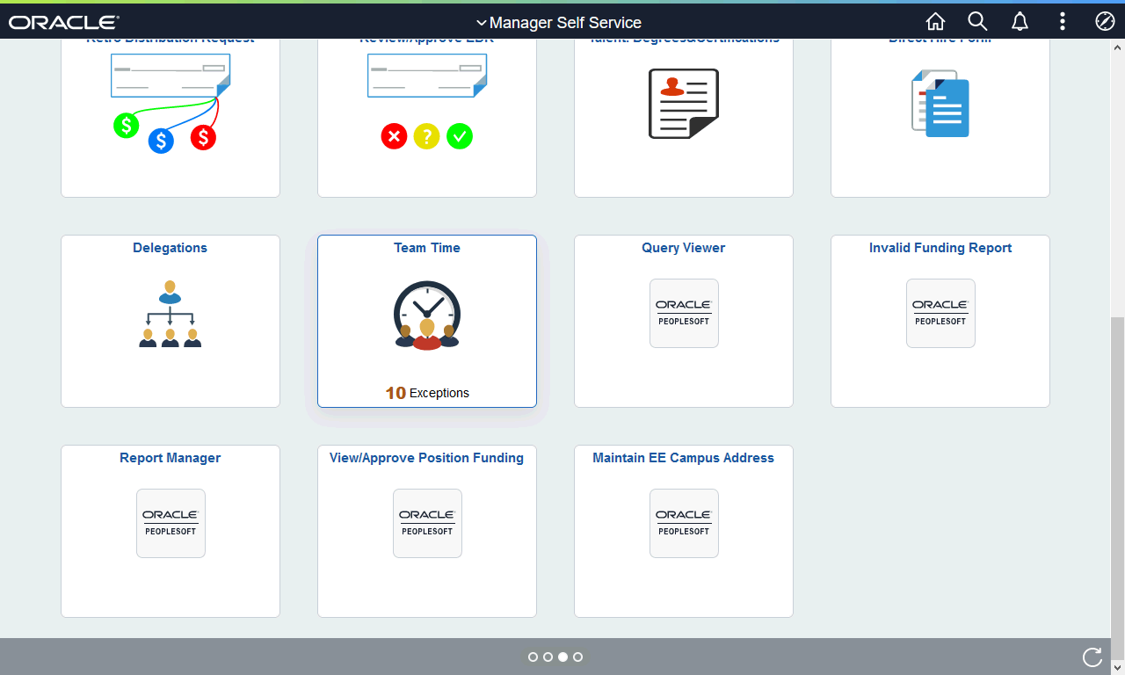

Step | Action
From the Manager Self Service homepage in OneUSG Connect, click the Team Time tile.

Note: The tile displays the number of exceptions that exist.
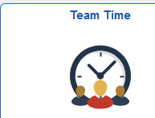
The Team Time page is displayed.

Click the Manage Exceptions link.
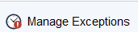
The Manage Exception page is displayed along with a detailed a list of employees who have Exceptions to address.

Note: If needed, you can use the filter tool to sort the employee timesheet exceptions you need to manage.
The exceptions reflected on the Fix tab are high exceptions that must be resolved on the timesheet for the employee to be paid.

Note: High exceptions are typically Invalid Punch Order exceptions (missed punches). Once corrected, you will need to approve the time change. Exception are cleared after approval and the periodic Time Administration process runs.
The Allow tab displays exceptions which are medium or low. Medium or low exceptions are managed using the "Allow" option.

To view the medium / low exceptions, click the Allow button.
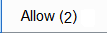
The Allow tab is displayed with a list of employees who have medium exceptions.

From the Exceptions list, select the checkbox to the left of the employee name.
To allow exception(s) for the selected employee, click the Allow button.

Note: If the exception should not be allowed, you will need to resolve it directly on the timesheet.
 | A message is displayed indicating the allowed exceptions were submitted successfully.
You have completed the steps to manage exceptions as a supervisor on employee timesheets in the OneUSG Connect system.
End of Procedure.

