Edit Previous Pay Period Hours – Biweekly Employees
Managers can edit hours from a previous pay period (up to 28 days prior in the current calendar year) for employees; once entered, the hours will need to be approved and will then be adjusted on the next normal payroll cycle. If an adjustment is needed further than the 28 days or for the previous calendar year, please contact the payroll department.
- Manager Self-Service Team Time Report Time
- Select Get Employees
- Click the last name of the employee
- The timesheet will open to the current pay period; change the Date field to the date that hours need to be entered for and click the green refresh arrows or use the Previous Period link to navigate to the correct dates.
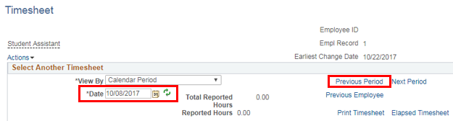
- Edit the hours for the correct dates and click the Submit button
- Approve these hours under the Reported Time Status tab on the timesheet
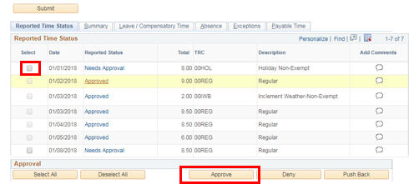

- These hours will be adjusted on the next normal payroll cycle

