How to submit an absence request:
- Open your timesheet (Self-Service Time & Absence Weekly Timesheet)
- Click the Absence tab below the Submit button
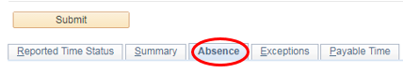

- Click the Add Absence Event button
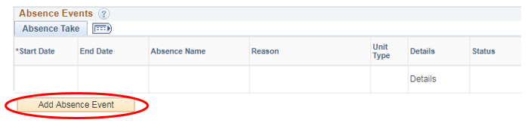

- Select the Start Date, End Date & Absence Name
- Click the word Details under the Details column and the absence details window will open. If you are requesting a full day absence for all days click the Calculate Duration button, verify the total hours are correct, click OK. If you are requesting partial days, select the appropriate option using the Partial Days drop-down menu, click the Calculate Duration button, verify total hours are correct, then click OK.
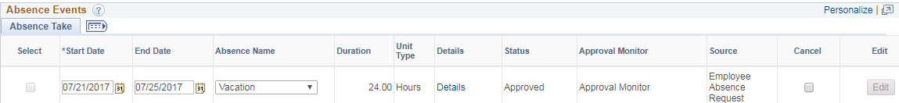

- Once you click OK, you will be taken back to your timesheet and will need to click the Submit button. This will send the absence request to your time & absence approver.

