VSU Graduate School Newsletter October/November, 2023

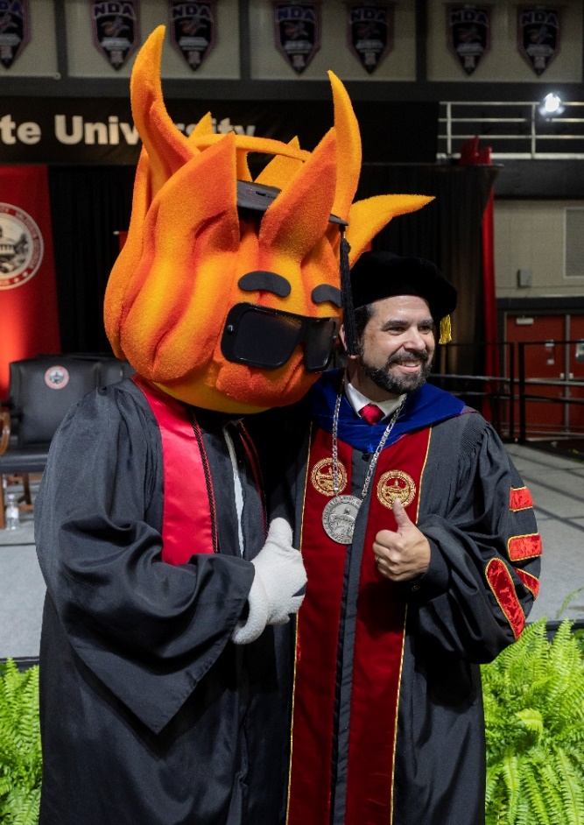
Fall 2023 Commencement
Congratulations to those who will be Graduating in December. The deadline for submitting your graduation application is October 27th. Please work with your advisor to submit your application. The graduation application fee $25, which can be paid electronically. To help us plan a great ceremony, please indicate on the application whether you plan to attend commencement.
For more information on Commencement visit the Commencement website
We are excited to celebrate you and this milestone in your career!

Be a part of AGS (Association of Graduate Students) by attending meetings each month. The general meetings are held in Odum Library 1629 (Graduate Study Room) or you can join the meetings online via Teams.
UPCOMING MEETINGS:
- October 23rd 5:00PM-6:00PM with Dr. da Cruz the Associate Provost for Graduate Studies and Research
- November 27th 5:00PM-6:00PM join us to see “How to Destress”

DID YOU KNOW? If you attend 3 or more AGS meetings, you are eligible to receive a cord to wear at commencement!!

VSU Graduate School Newsletter October/November, 2023
DID YOU KNOW?
The Academic Support Center provides graduate students writing support and assistance with SPSS. You can meet in person or online through Tutor.com. For more information visit the ASC website.

IMPORTANT DATES
October 3-4: Grad Finale: Student Union—1st floor by the Bookstore
October 9-10: Fall Break
October 23: AGS Meeting
October 25: Fall Career Expo: The Pursuit of a Job (Student Union Ballrooms)
October 27: Graduation application deadline to apply for Fall 2023 Graduation
October 30: Registration Begins for Spring and Summer
November 17: Fall 2023 dissertation & thesis deadline (submission to Graduate School)
November 23-24: Thanksgiving Break
November 27: AGS Meeting

